1) Dataset Preparation

1.1)Loading the dataset:

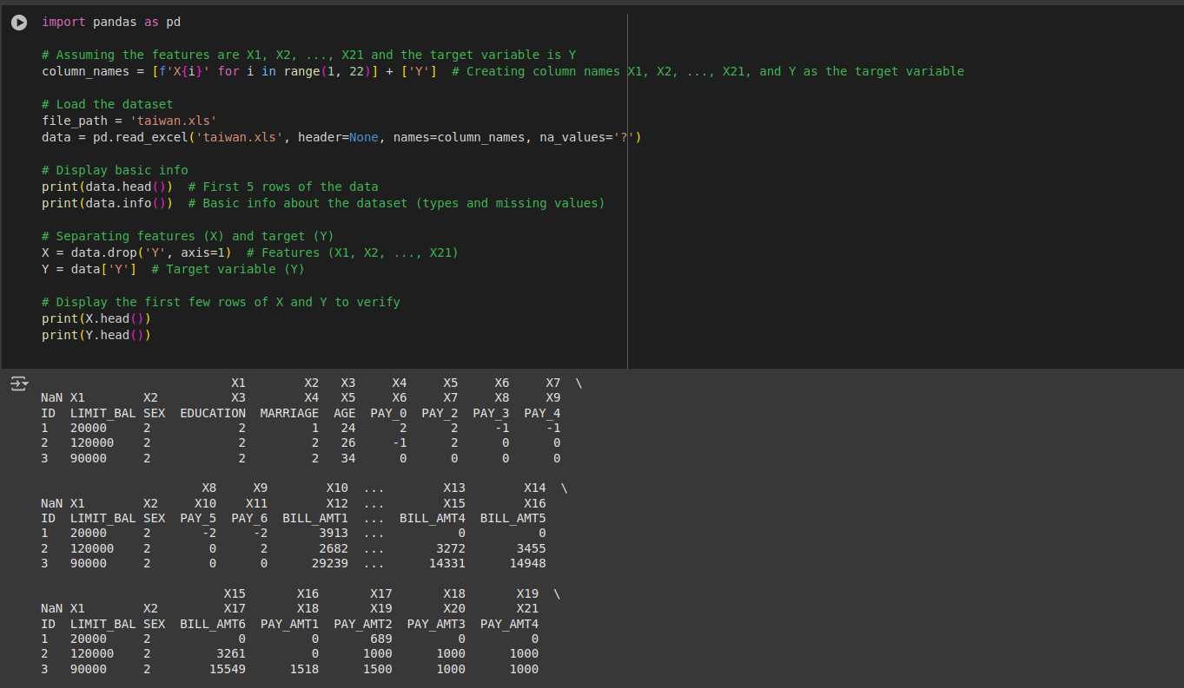

1.2) Handling Missing Values:

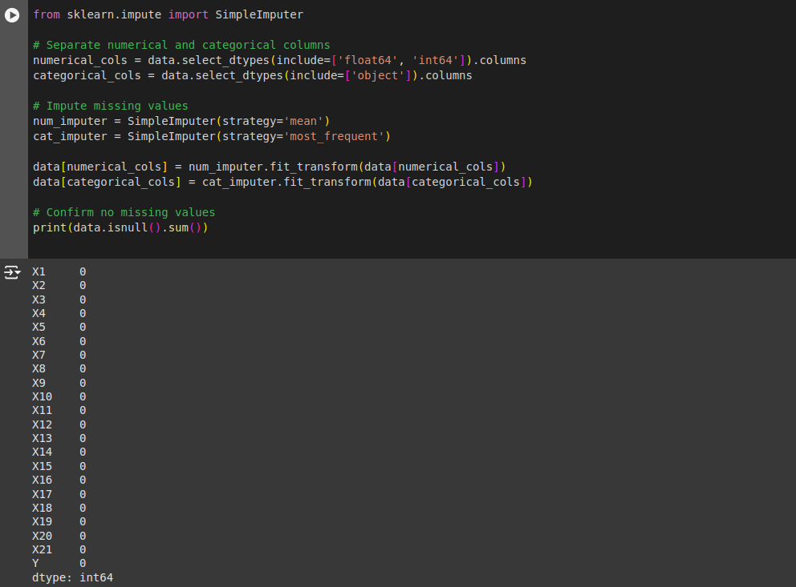

2) EDA :
2.1) Understand Data Distribution

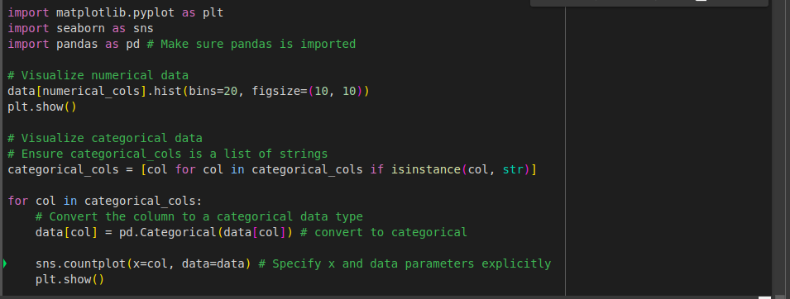

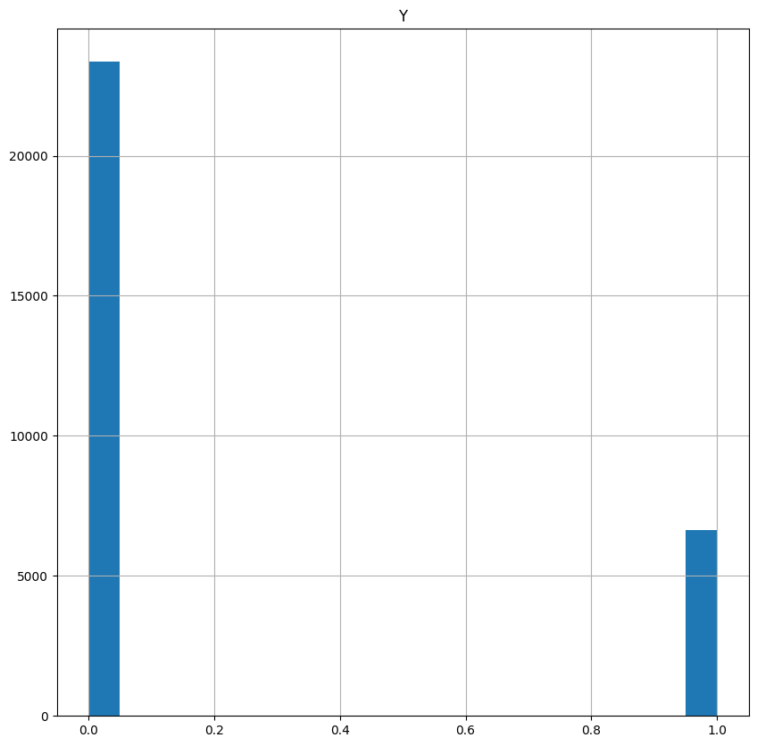
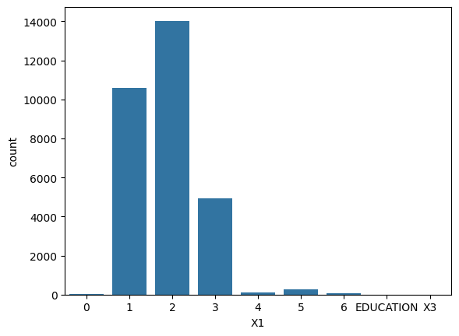

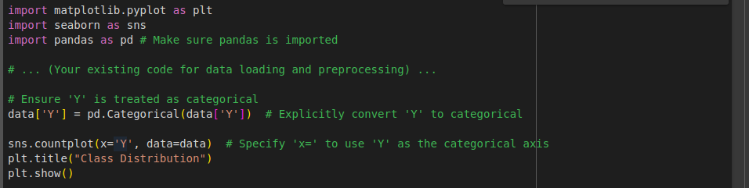
2.2) Class balance

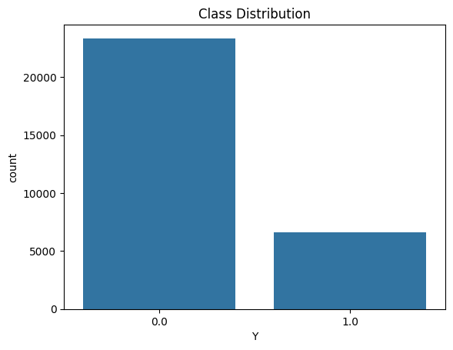

2.4) Outlier Detection

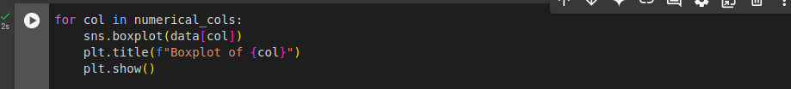
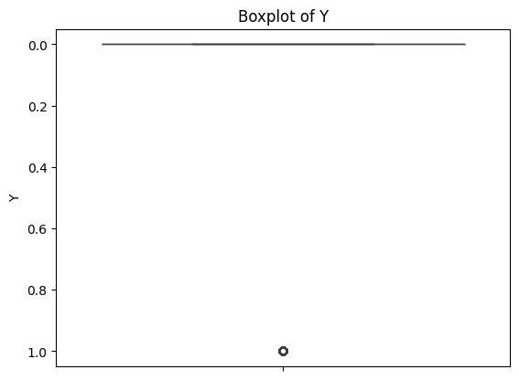

3) Train-test Split
3.1) Encode Categorical Data
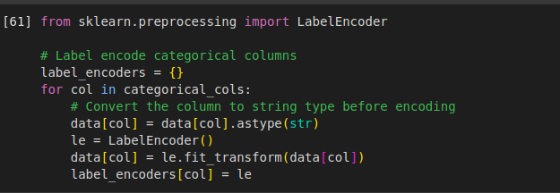
3.2) Split Data

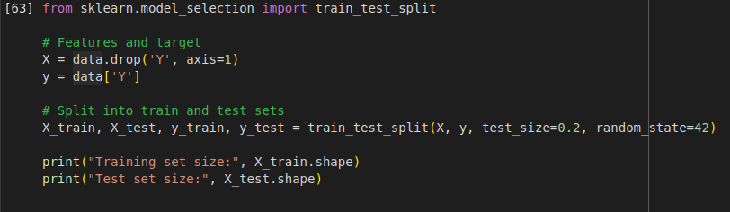
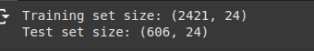

4) Applying ML Algorithms:
4.1) Logistic Regression
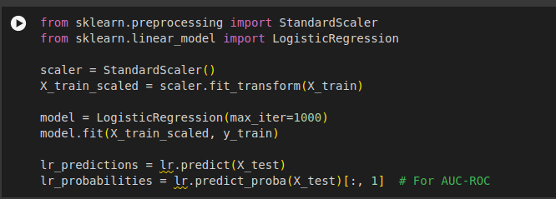

4.2)Decision Tree
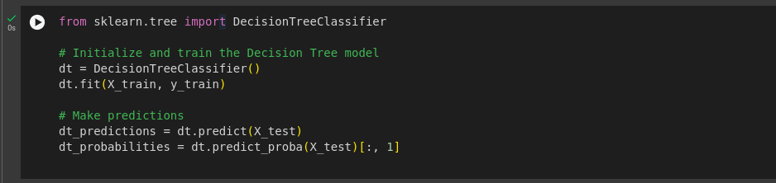

4.3) Random Forest

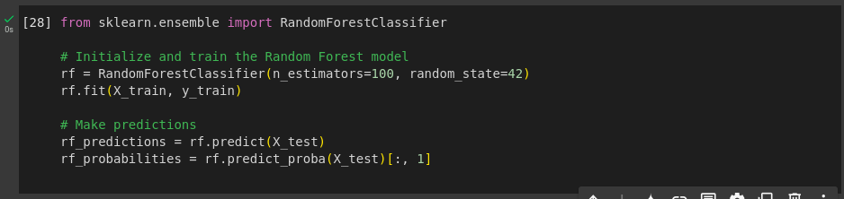

4.4) Gradient Boosting
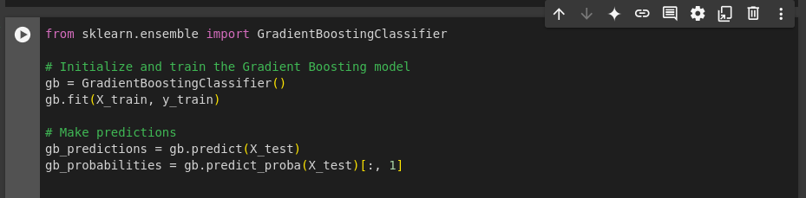

5) Evaluation Metrics

5.1) Evaluating Models
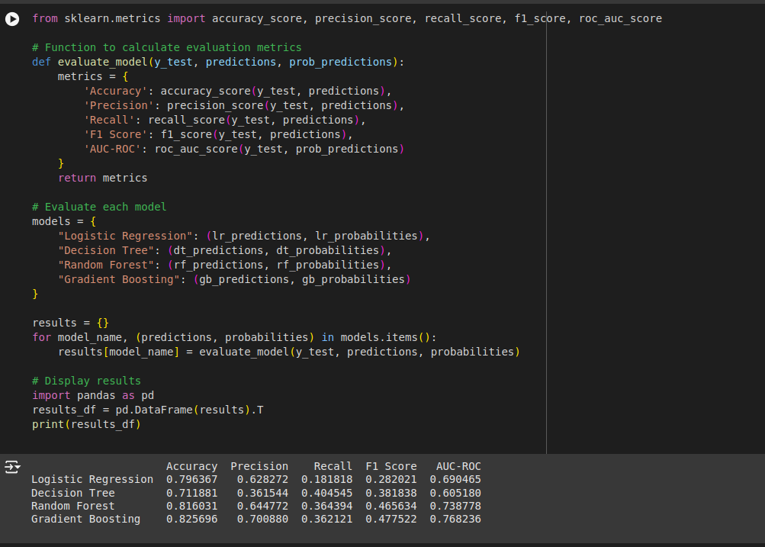

5.2) Plotting ROC Curves

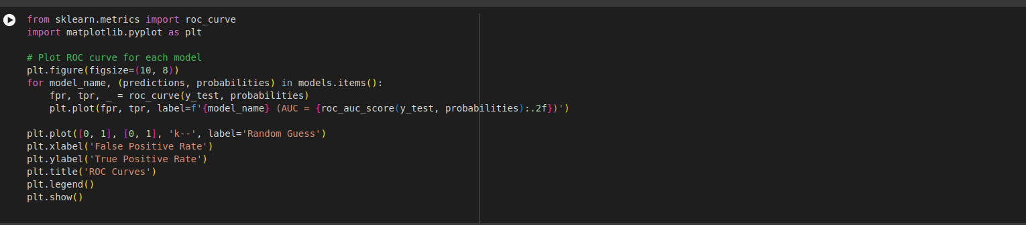
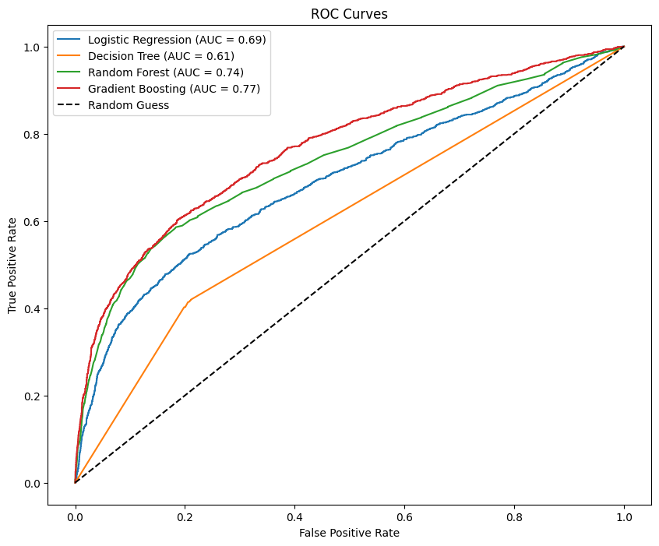

6) Comparing Results

Evaluation Metrics

- Accuracy: Overall correctness of predictions.
- Precision: Proportion of positive predictions that are actually positive.
- Recall: Proportion of actual positive cases correctly identified.
- F1-Score: Harmonic mean of precision and recall,
balancing both.
- AUC-ROC: Area Under the Receiver Operating Characteristic curve, measuring a model's ability to distinguish between positive and negative classes.

- Based on Evaluation Metrics
6.1)a) Accuracy

- Gradient Boosting and Random Forest have the highest accuracy, indicating they correctly classify the most instances.
- Logistic Regression has a lower accuracy but still performs reasonably well.
- Decision Tree has the lowest accuracy, suggesting it may be overfitting the training data.\

b) Precision

- Random Forest and Gradient Boosting have the highest precision, meaning they have a low false positive rate.
- Logistic Regression has a relatively high precision, but it's lower than the other two models.
- Decision Tree has the lowest precision, indicating it might be prone to false positives.

c) Recall

- All models struggle with recall, which means they have difficulty identifying positive instances.
- Logistic Regression has the lowest recall, suggesting it might be missing many true positive cases.
- Random Forest and Gradient Boosting have slightly better recall, but still relatively low.

d) F1-Score

- F1-Score considers both precision and recall.
- Random Forest has the highest F1-Score, indicating a better balance between precision and recall.
- Gradient Boosting and Logistic Regression have similar F1-Scores, suggesting a trade-off between precision and recall.
- Decision Tree has the lowest F1-Score, indicating a poor balance between precision and recall.

6.2) ROC Curves

a)Gradient Boosting

- It has the highest AUC-ROC score (0.78).
- This indicates that it has the best overall performance in distinguishing between positive and negative classes.
- It has a steeper curve, suggesting that it can achieve higher true positive rates with lower false positive rates.

b)Random Forest

- Has a good performance with an AUC-ROC score of 0.75.
- It's a strong contender, especially if interpretability is a concern.

c) Logistic Regression

- Has a decent performance with an AUC-ROC score of 0.71.
- It's a good baseline model and can be a good choice for simpler problems.

d)Decision Tree

- Has the lowest AUC-ROC score (0.58), indicating weaker performance compared to the other models.
- It might be overfitting the training data or underfitting the complexity of the problem.

6.3) Model Selection

a)Gradient Boosting

- Highest AUC-ROC score, indicating strong overall performance.
- Good balance between precision and recall.
- Often a powerful choice for complex classification problems.

b)Random Forest

- Solid performance across all metrics.
- Can handle complex decision boundaries and is less prone to overfitting

c) Logistic Regression

- While it performs reasonably well, it might struggle with complex datasets.
- It's a good baseline model and can be a good choice for simpler problems.

d) Decision Tree

- Lowest performance across all metrics, indicating potential overfitting or underfitting.

6.4) Conclusion

- Gradient Boosting: Best choice if we prioritize overall model performance based on AUC-ROC and precision.

- Random Forest: Preferred for a simpler model with good balance across metrics, especially for recall-focused applications.

